Difficulties of Upper lumber disc herniation Management
Momen M. Almamoun ¹, Ali R. Hamdan ²
¹Department of neurosurgery Faculty of medicine, Sohag University, Egypt
² Department of neurosurgery Faculty of medicine, South Valley University, Qena, Egypt

ABSTRACT
Disc herniation at the upper lumber levels (L1-2, L2-3, and L3-4) constitutes approximately 5% of all cases of lumbar disc prolapsed(1,10,12)
Preoperative symptoms and signs are highly variable. Sensory, motor, and reflexes are potentially misleading in suggesting the level of herniation.(1). Sensitivity and specificity of MRI in the diagnosis of disc herniation ranged from 71: 100% and from 50: 86 % respectively (15) Intraoperative X-ray is needed to localize the level of disc surgery(1)
Study Design: it is a retrospective clinical study
Objective: This study was conducted to study the unique clinical presentation and the operative outcome of the patients presented with high lumber disc prolapsed.
Patients & Methods: It's a clinical retrospective study harboring upper lumber disc prolapse that includes surgical management of 17 patients and the effect of surgical management on the outcomes starting from June 2009 to june 2014. Surgery was performed for all patients with failed medical treatment for at least 4 weeks or in case of neurologic deficit, Standard posterior bilateral laminectomy and discectomy was done and 2 patients required facetectomy for foraminal decompression and patient with recurrent disc and that with fracture pars all had transpedicular screw fixation and 1 cage. All surgeries were done with the image intensifier to localize the level of the disc prolapsed. Results: seventeen patients of upper lumber disc prolapse were included in this study; fourteen patients (82.4%) were males while three patients (17.6%) were females. The age range was 18-63 years. As regard the occupation thirteen patients were hard workers (constructions & farmers), three were house wife and one was official employer. Back pain was presented in all patients, upper thigh pain was presented in twelve (70.6%) patients, four (23.5%) patients presented with sciatic pain, thirteen (765%) with parathesia, nine (52.9%) with motor weakness and four (23.5%) with sphincteric disturbance. On examination, there were positive Straight Leg Raising (SLR) test in five (29.4%) patients, femoral stretch in ten (58.8%) patients. Sensory hyposthesia at different dermatomal distribution at different levels was present in all patients. Two (11.8%) patients had complete cauda equine, one (5.9%) patient had right lower limb monoplegia and incomplete cauda equine lesion in three (17.6%) patients. The outcome was assessed based on Odom criteria (Excellent, Good, and Bad). Patient was followed up after 1weak, 2 weeks 1 month and then every 6:12 week for at least 2 years.
- Conclusion: Herniated discs at the L1–L2 or L2–L3 level are different entities from those at lower levels of the lumbar spine, Preoperative symptoms and signs are highly variable, Early radiologic investigation with MRI is recommended in suspected patients, Intraoperative X-Ray is mandatory to localize the level of disc at surgery, non operative treatment of high level LDP has a less improvement rate than that at L 4-5 – L 5-S1 level and so surgery is indicated earlier, excellent and good outcome ranged from 80%to 93%, and due to anatomically narrow canal at upper lumber spine wide decompression and fixation is recommended
Introduction
Disc herniation at the upper lumber levels (L1-2, L2-3, and L3-4) constitutes approximately 5% of all cases of lumbar disc prolapsed (1, 10, 12)
Preoperative symptoms and signs are highly variable. Sensory, motor, and reflexes are potentially misleading in suggesting the level of herniation (1). Sensitivity a specificity of MRI in the diagnosis of disc herniation ranged from 71: 100% and from 50: 86 % respectively (15). Intraoperative X-ray is needed to localize the level of disc surgery (1).
The concurrent study was conducted to study the clinical features and post-operative outcome of surgical management of upper lumber disc prolapse.
This study was conducted to study the unique clinical presentation and the operative outcome of the patients presented with high lumber disc prolapsed.
Patients and methods
17patients with upper lumber disc prolapse were subjected to this study between june 2009 to june2012 at Qena University hospital.
Patient selection:
Patients with upper lumber disc prolapse (L1-2, L2-3, and L3-4), admitted to our department within 3 years. and followed up at out patient clinic clinically for at least 2 years

Initial assessment:
All patients were assessed clinically before treatment by history taking, general and neurological examination. Data were collected in standardized patients` sheet.
Routine laboratory investigations were done to all the patients including complete blood picture (CBC), prothrombin time (PT), partial thromboplastin time (PTT), liver function tests and kidney function tests. Disc prolapse was diagnosed on MRI lumbo-sacral .

Operative technique:
Surgery was indicated in patients with failed medical treatment for at least 4 weeks or in case of neurologic deficit. Standard posterior bilateral laminectomy and discectomy was done in 14 patient. And 3 patients needed fixation. 2 patients required facetectomy for foraminal decompression and patient with recurrent disc and that with fracture pars all had transpedicular screw fixation (PLIF) and 1 cage. All surgeries were done with the image intensifier to localize the level of the disc prolapsed.
Post-operative outcome:
The outcome was assessed based on Odom criteria (Excellent, Good, and Bad)(19).
Results
We studied the outcome of surgical treatment of upper lumber disc prolapse .
The age range was 18-63years, with a mean of (40.5 years). Gender distribution was predominantly male 14 patients (82.4%).

Fig (1):Sex distribution

Fig (2)Type of work
The clinical picture of the patients was as follow back pain was presented in all patients, upper thigh pain was presented in 12 (70.6%) patients, four (23.5%) patients presented with sciatic pain, 13 (76.5%) with parathesia, 9 (52.9%) with motor weakness and 4 (23.5%) with sphincteric disturbance.

Fig (3)Symptoms

Fig (4):Signs
MRI. Lumbosacral spine is the standard diagnostic tool. The level of disc prolapse was at L3-4 in 7 (41.2%) patients, L2-3 in 7 (41.2%) patients a L1-2 in 3 patients. 3 (17.6%).one patient had fracture pars , and one patient presented with recurrent disc after 5 years of the first surgery at the same level.

Fig (5):Level of disc prolapse
Patients were followed up after 1weak, 2 weeks 1 month and then every 6:12 week for up to 2 years after surgery. The outcome was assessed based on Odom criteria (Excellent, Good, and Bad).

Leg pain was improved in all Patients and all back pain complain was recovered except in 5 (29.4%) Patients who had occasional back pain that was improved with medications and do not affect the daily activity. Weakness improved to full power in 14(82.4%) patients and to G 3:4 in 2 (11.8%) Patients who were G 0. One Patient was flaccid paraplegia did not improve. As regard autonomic disturbance 2 (11.8%) patients became content and 2 (11.8%) did not improve. No Patient was deteriorated. Intra operative unintended durotomy occurred in 2 (11.8%) patients immediate water tie repair was done with post-operative medications and precautions and no CSF leakage occurred. No any minor or major wound infection occurred. No any manifestation of discitis occurred.

Fig (6):Post operative outcome
DISCUSSION
Lumber disc prolapse at upper level constitute 5% of all lumber disc hernistains (1, 2, 3). Some author consider the upper lumber disc is the T 12-L1, L 1-2 and L 2-3(4) others consider L 1-2, L 2-3 are only the upper disc level (5). And others consider it the level L 1-2, L 2-3, and L3-4 are the upper level (1)
The low incidence of disc prolapse at upper lumber level is due to different anatomical and biomechanical factors as decreased motion(6) also associated other concomitant spinal abnormalities(compression fracture limbus vertebrae and retrolisthesis) that change the dynamics and stress on the upper lumber disc predisposing them to herniation (4)
Age can be considered as factor in pathogenesis of disc herniation at the L 1-2, L 2-3 level and may precipitate the development of abnormal spinal dynamics that lead to upper lumber disc herniations. The mean age was 63 years in Sanderson et al, (5), 51.6 years in Albert, et al (1), 54.6 years in Kim, et al (7) 57.5 years in Sedighi and Haghnegahdar(20)

In this study the age ranged from 18 to 63 years with average of 40.5 years.
In Albert et al series (1) there were 102 men and 39 women and in this study there were 14 males and 3 females.
The typical clinical presentation of an upper lumber disc herniation is usually anterior thigh pain and | or groin pain (5).
Albert et al 1993(1) reported that pre-operative signs and symptoms were highly variable, and potentially misleading in suggesting the level of herniation.
Patients with upper lumber disc herniation are reported to have normal straight leg raising test (SRL) and the femoral stretch test is positive in 84 to 94 % of Patients (8). But Sedighi and Haghnegahdar(20) found positive straight leg raising test in 18 patient of there 23 patient with upper level LDP.
Paresis and autonomic disorders occur much more frequently in upper lumber disc herniation than in lower disc herniation (10). Paresis of the lower abdominal wall with pain radiated to the inguinal region was described as the only presentation of L 1-2 disc prolapse (11).
Cauda equine syndrome was high (63%) in Wei et al series (12) and Cedoz, et al reported 5 of 24 patients (20.8%)had cauda equina syndrome (13)
For sensory loss. Fine touch can be more reliably assessed than pain (14). Dermatomal pain distribution has 90% sensitivity (15).
In this study upper high pain was found in 12 patient's 70.5%. Sciatica in 4 (23.5%) patients, Femoral stretch test was positive in 10 (58%) patients And SLR in 5 (29%) patients. 2 patients had complete cauda equina and other 10 had incomplete cauda equine lesion.
Pasztor and Sazarvas reported paresis in 50% of the patients and autonomic disturbance in 26.9 %( 10)
In this study the sphincter disturbance was found in 4 (23.5%) patients
Sensitivity a specificity of MRI in the diagnosis of disc herniation ranged from 71: 100% and from 50: 86 % respectively (15).
All patients in this study had MRI for diagnosis which was satisfactory in all patients. Additional plain X-ray at different views and C.T. spine helped in case of fracture pars.
Codez, et al 1996 found in his series of 24 patients 7 patient. at L 1-2 and 17 at L2-3(13). Sanderson, et al 2004 had 20 patients with L 1-2, L 2-3 and 52 patients with L 3-4 level (5).
Where Albert, et al 1993 find 3 patients with L 1-2 DP. , 21 patient with L 1-2 and 117 with L 3-2 DP(1).
Kim , et al 2003 had 5 patients L 1-2 , 21 patient , L 1-2 (7), Jian et al 1997 repeated 2 patient e L1-2 , 3 at L 2-3 and 34 at L3-4(16)
In this study there were 3 patient at L 1-2, 7 at L 2-3 & 7 at L 3-4
When surgery is indicated for patients with upper level lumber disc prolapse. Inter laminar approach is difficult due to different anatomical factors.
- The interlaminar space is smaller in all dimensions.
- The inferior border of the superior lamina over hangs the disc space to a greater extent.
- The spinal canal is smaller and contains more volume of neurologic tissue.
- The nerve roots leave the spinal canal in a more horizontal fashion than L 5 and S 1 roots (17)
Kim et al 2009. Reported that oblique Para Spinal approach is a safe and effective procedure for the treatment of disc herniation of the upper lumbar spine (7).
Mc Culloch, 1996(17), and Sanderson, et al, 2004(5) reported that it is possible to use the micro surgical approach to remove disc herniation at the higher lumber region.
In this study we used the standard posterior microsurgical approach with bilateral laminectomy for treating all patients.
The Outcome after surgery at high lumber level in different.
Albert, et al 1993 (1) Reported that 80% had an excellent or good outcome at a mean of 26 years., Pasztor and Szarvas 1981(3) reported a 93 % excellent or good early post-operative outcome and a 82% . At late outcome, Sanderson et al 2004(5) reported excellent and good outcome in 87 to 94 % of patients.
Lurie et al (18) reported that non operative treatment of high level LDP has a less improvement rate than that at L 4-5 – L 5-5 level and so surgery is indicated earlier and Jim et al 2005(7) reported 78% patient satisfaction rate.
In this study Overall improvement occurred in 15 / 17 patients 88%, and back pain win 12 / 17 patients 70%
Patients who did not improve are those with G 0 motor power preoperatively and urine incontinence.
Pasztor, et al 1981 Reported that less marked improvement occurs in patients with motor and autonomic disturbance Sedighi and Haghnegahdar(20) said that surgery at upper level LDP has better outcome compaired with L4-5 and L5-S1 levels
Conclusion
Herniated discs at the L1–L2 or L2–L3 level are different entities from those at lower levels of the lumbar spine, Preoperative symptoms and signs are highly variable, Early radiologic investigation with MRI is recommended in suspected patients, Intraoperative X-Ray is mandatory to localize the level of disc surgery
non operative treatment of high level LDP has a less improvement rate than that at L 4-5 – L 5-5 level and so surgery is indicated earlier , due to anatomically narrow canal at upper lumber spine wide decompression and fixation is recommended, excellent and good outcome ranged from 80%to 93%

Limitations: The limitation of our study is the small number of cases.
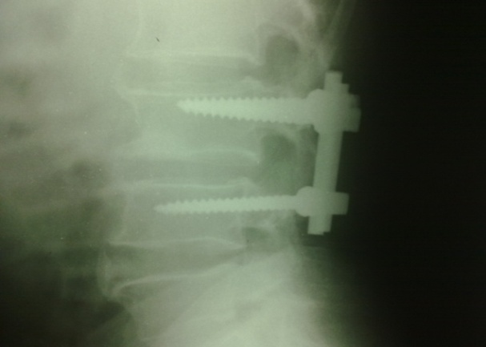
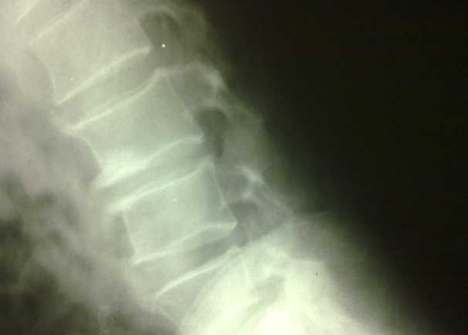
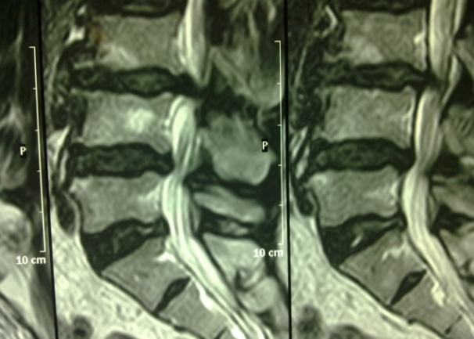
Patients presentation:
Plain X Ray lateral view Post op. with fixation Fig (9):
Plain xray lateral view of the previous patient Fig (8):
Fig (7): MRI LS Spine T 2 shows Patient with L3-4 disc
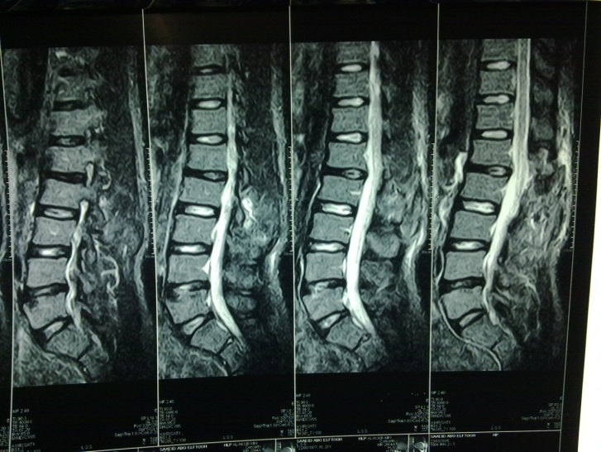
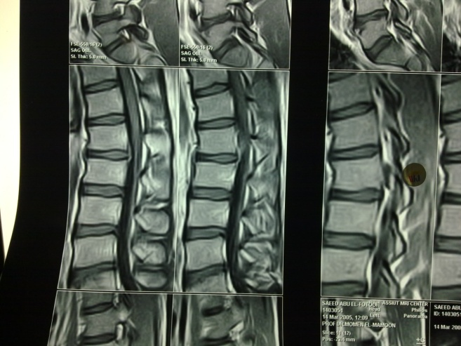

Fig (11):MRI LS spine T 1 sagital post operative
Fig (10):MRI LS spine T 1 sagital shows L1-2 DP with upward migration

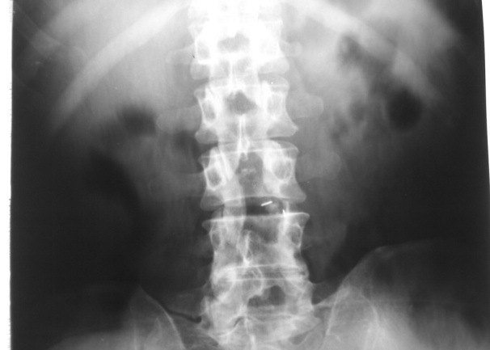
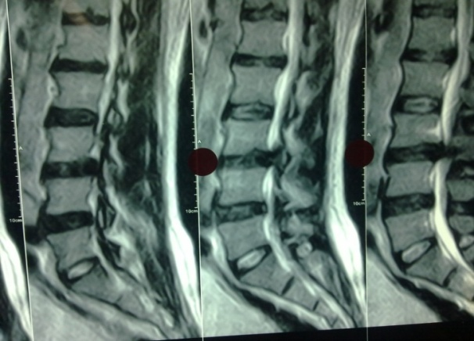

Fig (13):Plain X Ray AP view Post op.L3-4 Unilateral Cage after facetectomy
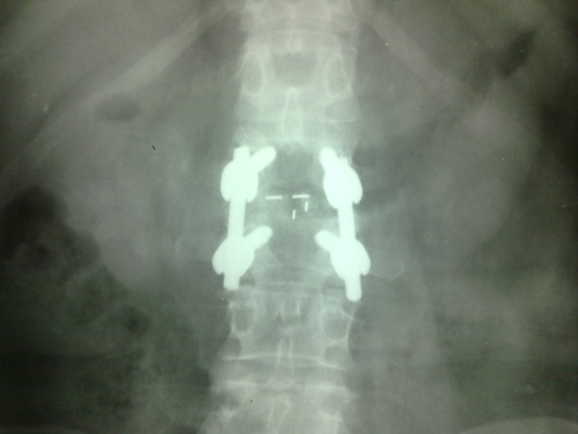
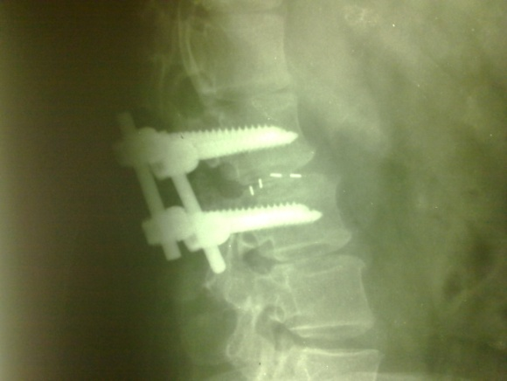
References
Fig (15):Plain X Ray AP view Post op.L2-3 inter body fusion
Fig (14):Plain X Ray lateral view Post op.L2-3 inter body fusion
Fig (12):MRI LS spine T 2 sagital shows L3-4 DP
- Albert TJ. Balderson RA, Heller JG, Herkowitz HN, Garfen SR, Tomany k, An HS, Simeone FA: Upper lumber disc herniation. J spine Disord 6: 351 – 359, 1993.
- Kortenlainen P, Puranen J, and Koivisto E, Lähdo S: Symptoms and signs of sciatica and their relation to the localization of lumber disc herniation. spine 10 : 88 – 92 , 1992
- Pasztor E, Szarvas I: Herniation of the upper lumber disc. Neurosurgery Rev 4: 151 – 157, 1981
- HSUK, Zucherman J, Shea W: High lumber disc degeneration, incidence and etiology. Spine 15: 679 – 682, 1990
- Sanderson SP , Houten JH .Errico T , Forshaw D, Bauman J and Cooper PR :The unique characteristics of "Upper" lumber disc Herniation Neurosurgery 55, 2 357 – 389. 2004
- Fantanosi G , Tartaglia I , Cavazzuti A, Giancecchi F: Prolapse inter vertebral disc at the upper lumber level, Ital J orthop traumatol 13: 501 – 507. 1987
- Kim , J – S , Lee SH , moon , KH , Lee HY : Surgical Results of the oblique pan spinal Approach in Upper Lumber Disk Herniation And thoracho lumber junction. Neurosurgery 65:1. 95 – 99 Jul 2009
- Estridge MN, Rouhe SA, Jonson NG. The femoral stretch test: A valuable sign in diagnosing upper lumber disc Herniation. J Neurosurgery 57: 813 – 817, 1982
- Nadler SF, Campagnole DL, Tomaio AC, Stitik TP: High Lumber disk: Diagnostic and Treatment dilemma.Am J phys Med Rehabil 77: 538 – 544, 1998?
- Paszter E , Szarvas I , : Herniation of the upper lumber disc Neurosurgery Rev. uc3 : 151 – 7 1981
- Billet H, Ponssen H, and Veenhuizen D: Unilateral paresis of the abdominal wall: a radicular syndrome caused by herniation of the L 1-2 discs? J Neurol Neurosurgery psychiatry: 52: 6786 - 1989
- Wei CP ,Cheng WC ,Chang CN , Lee ST ,Lui TN , Wang AD: Upper lumber disc herniation.Changgeng Yi Xue Za Zhi, Dec 2012 (4) 193 – 9 1989 (Pub Med)
- Codoz ME ,Labre JP , Lequin C , Fischer G ,Liroa G : upper lumber disk herniation. Rev Rhum Engl Ed. 63c6): 421 – 6 Jun 1996
- Vroomen PCAJ, Marc CTFM de krom , and Kno HneruS JA : consistency of History taking and physical Examination with suspected lumber nerve Root Involvement, Spine 25(1): 91 – 97 2000
- Vroomen PCAJ , de krom CTFM , Wilkmink JT , Kester AD , Kno Hnerus JA :

Diagnostic value of history and physical Examination in patients suspected of lumbosacral nerve root compression.

J Neurol Neurosurg psychiatry 72: 630 – 634 2002
- Jian. F, Xia TR, Sheng HS, et al: upper lumber disc herniation. Chines. Jeurnal of spine and spinal cord 1997 – 06
- Mc Culloch, JA., Focus Issue on lumber disc herniation: Macro–and Micro discectomy Spine 21. 245, 455 – 565, 1996
- Lurie , JD , faucet SC, Hanscom B Tosteson TD ,et al Lumber Discectomy Outcomes vary by Hernaition level in the spine patient outcomes Research Trial The Journal of Bone and joint surg Am, 2008 Sept. 01: 90 (9) 1811 – 1819
- Odom,GL, Finney W, Woodhall B. Cervical disc lesions JAMA 1958;166:23-28.
- Mahsa Sedighi and Ali Haghnegahdar, Lumber Disk Herniation Surgery: Outcome and Predictors, Global Spine Journal, 4 (4).December 2014, 233-243

